Business Continuity and Disaster Recovery
Business continuity (BC) and disaster recovery (DR) are intrinsically related – and in most scenarios DR is considered a subset of BC. The former may not be security driven – for example the 2020 worldwide pandemic caused by Covid-19 led to many businesses invoking their BC plans to cope with government mandated shutdown to keep their business' working by allowing many staff to work from home.
However, although the invocation was not security related, the change in business activities had a major impact on businesses security risks and policies. For example, when staff work from home their employers need to ensure that the equipment they use is up to date with security patches; that they have a secure method of accessing business documents; that any documents stored locally are also
held securely (I.e. by the use of encryption); that their home IT infrastructure is secure and has not been compromised (e.g. do they have a firewall? Is it patched up to date? Do they have any unusual configuration settings, etc). Some of these questions can be managed by technology, others may need policy and procedure changes.
Both BC and DR plans are driven by business requirements and should form part of an overall enterprise architecture design, including the security architecture. One of the most commonly used architecture frameworks is TOGAF (the Open Group Architecture Framework). The architecture development method (ADM) is shown in figure 1, together with the modifications due to the SABSA (Sherwood Applied Business Architecture) model. 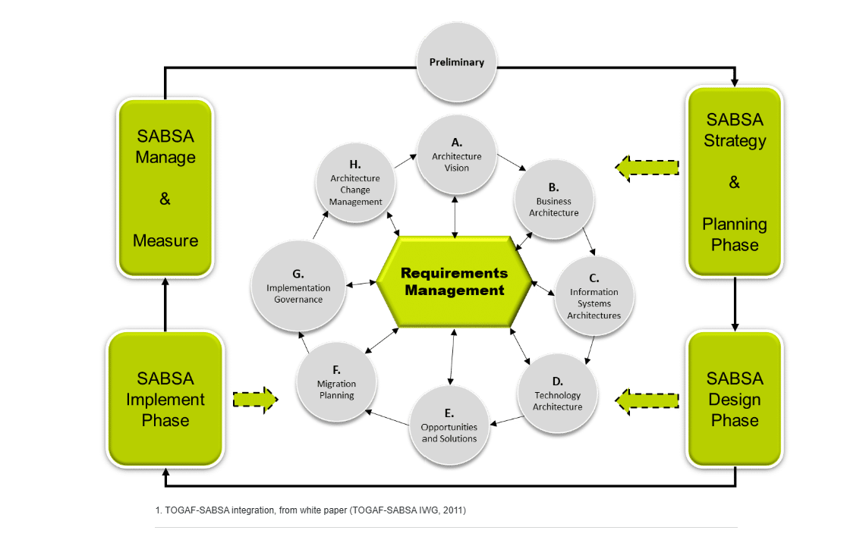

1. Business Continuity (BC)
Business Continuity is the organisation's ability to continue operating during and after a disruption.
The goal is:
"Keep the business running."
Disruptions could be:
- Cyberattack
- Fire
- Flood
- Power outage
- Pandemic (COVID-19)
- Staff shortages

Example
During COVID-19:
- Offices closed.
- Employees worked from home.
- The business continued operating.
This is Business Continuity in action.

Cybersecurity Example
A ransomware attack shuts down the office network.
BC plan may require:
- Staff to work from alternative systems.
- Customer support to operate from backup locations.
- Essential services to continue.

2. Disaster Recovery (DR)
Disaster Recovery focuses specifically on restoring IT systems and data after a disruption.
The goal is:
"Recover technology and information systems."

Example
A ransomware attack encrypts:
- Servers
- Databases
- File storage
DR plan includes:
- Restore backups
- Rebuild servers
- Recover applications
- Verify systems

Cybersecurity Example
A company restores data from immutable backups after ransomware.
This is Disaster Recovery.

Relationship Between BC and DR
Business Continuity
│
└── Disaster Recovery
Think of it like:
- BC = Keep the business alive
- DR = Fix and restore the technology

3. Why COVID-19 is Mentioned
COVID-19 was not a cybersecurity incident.
However, it created new security risks:

Employees Working from Home
Risks:
- Unpatched laptops
- Weak home Wi-Fi
- Shared family computers
- Data leakage
- Unsecured documents
Controls:
- VPN
- MFA
- Encryption
- Security awareness training
- Patch management

4. Enterprise Architecture
Enterprise Architecture is the blueprint of the organisation.
It describes:
- Business processes
- Applications
- Technology
- Security
Think of it like an architect's blueprint for a building.

5. TOGAF
TOGAF (The Open Group Architecture Framework) is one of the most popular frameworks for designing enterprise architecture.
It helps organisations answer:
- What do we want?
- How should systems work?
- What technology is required?
- How do we implement it?

6. SABSA
SABSA (Sherwood Applied Business Security Architecture) is a security architecture framework.
It focuses on:
Aligning security with business requirements.
Instead of asking:
❌ "What firewall should we buy?"
SABSA asks:

✅ "What business risk are we trying to protect against?"
Easy Memory Trick
BC = Business survives
DR = Data recovers
TOGAF = Business architecture
SABSA = Security architecture

7. Understanding the Diagram
The diagram shows how TOGAF and SABSA work together.

A. Architecture Vision
"What are we trying to achieve?"
Example:
- Secure online banking system.

B. Business Architecture
"How does the business operate?"
Example:
- Customers transfer money.
- Staff process payments.

C. Information Systems Architecture
"What information and applications are required?"
Example:
- Customer database
- Banking application

D. Technology Architecture
"What technology supports the systems?"
Example:
- Servers
- Networks
- Firewalls
- Cloud services

E. Opportunities and Solutions
"What security solutions can we implement?"
Example:
- MFA
- SIEM
- Immutable backups

F. Migration Planning
"How do we move from current state to future state?"
Example:
- Migrate from passwords to MFA.

G. Implementation Governance
"Are we implementing correctly?"
Example:
- Security audits
- Compliance reviews

H. Architecture Change Management
"How do we adapt when business changes?"
Example:
- New cyber threats
- New regulations

8. Requirements Management (Centre of Diagram)
This is the heart of the process.
Every decision must support:
- Business requirements
- Security requirements
- Compliance requirements

Quick Exam Notes

Business Continuity (BC)
Ensures critical business operations continue during and after disruptions.

Disaster Recovery (DR)
Restores IT systems, applications and data after a disruption.

TOGAF
Enterprise architecture framework used to design and manage organisational architecture.

SABSA
Security architecture framework that aligns security controls with business objectives and risk.

Cybersecurity Example
An organisation hit by ransomware uses its Business Continuity Plan to continue customer services and its Disaster Recovery Plan to restore systems from immutable backups.
--

The Architecture Development Method (ADM)
- bullet
In the ADM, requirements are seen to be at the heart of the development model, as shown in the diagram.
- bullet
The SABSA model is also requirements driven, albeit using different terminology.
- bullet
The integrated model, as shown, provides the security element to a traditional enterprise architecture model.
A more detailed discussion can be found in the references (TOGAF-SABSA IWG, 2011).

Business Continuity (BC)
Business Continuity is defined as part of the ISO 22301 standard.
Adhering to the standard gives customers trust and confidence in a company, knowing that it has plans in place to deal with emergency situations and that it will be able to continue to do business even if a disaster should occur.
The standard recommends that a business:

Undergoes a risk assessment;

Undergoes a business impact analysis;

Selects a BC strategy;

Creates and implement policies and procedures;

Performs regular tests to ensure that the strategy is appropriate and;

Ensures that plans operate as expected.
BC planning is, as its name suggests, mostly concerned with plans and approaches that can be deployed to allow a business to continue to run in the event of a major disaster or incident – such as a fire, flood, cyberattack or as discussed above a global pandemic.
The BC plan deals with plans and procedures to ensure that the business and its staff can continue to operate in as close to normal a way as possible.

Disaster Recovery (DR)
Disaster recovery, on the other hand, is more concerned with ensuring that the IT infrastructure that supports the business and staff is available when the BC is invoked – as such it is part of the overall BC plan.
There are two factors in particular that drive the DR plan and design:
- bullet
The Recovery Time Objective (RTO)
- bullet
The Recovery Point Objective (RPO)
Both of these are usually derived from the BIA (read more below).
DR solutions can vary in scope and complexity by a vast amount – anything from a basic backup tape to a full hot standby system can constitute a DR solution – which is chosen is driven by the RTO, RPO and of course the cost requirements.

Business Impact Assessments or Analysis (BIA)
Business Impact Assessments or Analysis (BIA) will help the BC team quantify the impact on specific business functions of the risks and costs of a potential incident. This information in turn can be used to drive both business continuity and disaster recovery planning.

RTO (Recovery Time Objective) & RPO (Recovery Point Objective)

RTO
RTO determines how quickly the IT infrastructure needs to be recovered in the event of an incident, the shorter the RTO the more expensive the solution usually is.

RPO
RPO determines from what point the system needs to be recovered – that is how much data can the business afford to lose or can it recover in some other manner.
Again, the shorter the RPO the more expensive the solution.

- EXAMPLE 1

RPO = 24 Hours & RTO = 5 Days
For example, if the RPO is determined to be 24 hours, and the RTO 5 days then simply taking a nightly backup and recovering the system from that backup would meet the requirements – this is especially true in the days of Cloud provisioning where an alternative system can be built in the cloud in a matter of hours.
- EXAMPLE 2

RPO = 15 min & RTO = 50 minutes
If the RPO is 15 minutes or less, and the RTO is less than an hour then the only acceptable solution to meet these requirements would be a hot standby system where the alternative solution is already built (in the cloud or in a physical data centre) and the data from the primary system is continuously synchronised with it.

DR and Digitalisation
Disaster recovery (DR) is a major component of any business continuity (BC) strategy.
All businesses should have plans for both BC and DR – and both should be tested regularly. This is particularly true for companies undergoing digital transformation – where a loss of the (newly developed) IT facilities could prove disastrous in many ways.

Digitalisation Process
Disaster recovery (DR) is a major component of any business continuity (BC) strategy.
All businesses should have plans for both BC and DR – and both should be tested regularly. This is particularly true for companies undergoing digital transformation – where a loss of the (newly developed) IT facilities could prove disastrous in many ways.
Some authors such as Zaoui & Souissi (2020) who provide a review of current academic literature concerning digital transformation, or even Yamamoto (2020) who carries out a study of the digital transformation roadmap in Japan.
Altimeter, a digital/ cloud consulting company, produced a report about 'digital transformation maturity' (Solis, 2016) where they identified six stages within the transformation process. These were:
++++++====

Explanation :
🟢 Stage 1 – Business as Usual

Meaning
The company works the same way it always has.
It does not really use digital technologies to improve itself.
It has little understanding of customer needs.

Example
A small shop:
- Takes orders by phone.
- Uses paper records.
- Has no website.
- Doesn't analyse customer data.

🟢 Stage 2 – Present and Active

Meaning
The company realises:
"We need digital transformation."
They start experimenting.
However:
There is no organised plan.
Everybody tries different things independently.

Example
Different departments do different things:
- Marketing opens Instagram.
- Sales buys software.
- IT moves some files to the cloud.
But nobody coordinates the effort.
The onus is on the business to check and ensure that backups are made regularly and that there is a DR process that has been tested and is available – checking after the disaster has happened is almost always too late.

🟢 Stage 3 – Formalised

Meaning
Digital transformation becomes organised.
The company has:
- Digital leaders
- Visionaries
- Change agents
They begin asking management for support.
This is where executive buy-in appears.

Example
The company proposes:
"We need MFA, cloud migration and cybersecurity training."
They prepare a business case.
Now they need approval from senior management.

🟢 Stage 4 – Strategic

Meaning
The company has overcome internal resistance.
Everyone supports the digital transformation.
Now they build a strategic roadmap.
They ask:
"Where do we want to be in 3–5 years?"

Example
Roadmap:
2026 → Implement MFA
2027 → Move to cloud
2028 → Deploy SIEM
2029 → Zero Trust architecture
Everything becomes planned.

Virtualised servers are also easier to migrate to the cloud.

🎓 Cybersecurity Example (easier to remember)
Imagine a company introducing Multi-Factor Authentication (MFA).
Stage | Cybersecurity Example
Stage 1: Business as Usual | Only passwords are used.
Stage 2: Present and Active | IT experiments with MFA.
Stage 3: Formalised | A proposal is created and management approval is requested.
Stage 4: Strategic | MFA becomes part of a long-term cybersecurity roadmap.

Simple way to remember
Stage 1
"We do nothing."
↓
Stage 2
"We are experimenting."
↓
Stage 3
"We are organising."
↓
Stage 4
"We are planning strategically."

🎓 MSc one-line notes

Business as Usual
Traditional operations with little digital transformation.

Present and Active
Experimenting with digital technologies without a coordinated strategy.

Formalised
Organised digital initiatives with leaders seeking executive support.

Strategic
Digital transformation becomes part of a long-term business strategy.
Perfect, Payman. These are the last two stages of the Digital Transformation Maturity Model.
Think of the whole model as:
1. Business as Usual
↓
2. Present and Active
↓
3. Formalised
↓
4. Strategic
↓
5. Converged
↓
6. Innovative and Adapted
Now let's simplify the last two.

🟢 Stage 5 – Converged

Meaning
Digital transformation is fully integrated into the business.
The company creates a dedicated innovation team.
These specialists continuously improve the business.
Everyone is working towards the same digital goals.

Example
The company has a team responsible for:
- Cybersecurity
- Cloud migration
- AI projects
- Data analytics
- Automation
Instead of individual departments working separately, everyone works together.

Cybersecurity example
The company creates a Cybersecurity Transformation Team.
Their responsibilities:
- Implement Zero Trust
- Improve Disaster Recovery
- Monitor cyber risks
- Review security policies

🟢 Stage 6 – Innovative and Adapted

Meaning
Digital transformation has become part of the company's DNA.
The organisation can quickly adapt to change.
Innovation happens continuously.
The company is always ready for new technologies.

Example
The business can quickly adopt:
- AI tools
- New cloud technologies
- New cybersecurity solutions
- New regulations
Employees are comfortable with change.

🎓 Cybersecurity example
Suppose a new ransomware threat appears.
Stage 1 company:
"We don't know what to do."
Stage 6 company:
"We already have a process."
Actions:
- Threat intelligence team analyses it.
- Immutable backups exist.
- Incident response plan is activated.
- Employees are trained.
- Systems are patched quickly.
The company adapts easily.

📝 Easy memory trick
Stage | Think
1 | We do nothing
2 | We experiment
3 | We organise
4 | We plan strategically
5 | We work together
6 | We continuously innovate

🎓 One-line exam notes

Stage 5 – Converged
The organisation has a dedicated innovation team and digital transformation is integrated across the business.

Stage 6 – Innovative and Adapted
Digital transformation becomes a normal way of working, allowing the organisation to continuously innovate and adapt to change.

⭐ Very short revision sentence
A digitally mature organisation evolves from doing nothing (Stage 1) to continuously innovating and adapting (Stage 6).
Question (your standing rule): Would you like to delete or keep our current conversation?
Digitalisation may be triggered by numerous internal or external events. For example, in the UK the Government has decided that tax reporting should be digital, and there are several initiatives around how the process should be adopted or integrated into normal business processes.

Another example may be the creation of an online presence used for marketing or even as a simple e-commerce portal. In many cases, these services are created and managed by third-party web hosting companies, often using frameworks such as WordPress, Drupal, or Joomla.
In many cases, the third parties manage backups and can also provide the digital aspect of the DR process if required.

The onus is on the business to check and ensure that backups are made regularly and that there is a DR process that has been tested and is available – checking after the disaster has happened is almost always too late.
Example: The onus is on the business = The business is responsible for ensuring the necessary actions are taken.
STAGE 4
A typical example of the strategic phase is the adoption of a virtualisation strategy. Many companies who invested in IT equipment ten or more years ago may find that the next stage of their digital journey is the adoption of virtualisation technology.
Virtualised servers are also easier to migrate to the cloud.

This has many benefits from a cost savings/sustainabiity point of view (less power consumed and heat produced, a reduction in the number of physical servers leading to lower cost hosting in data centres), to DR considerations (because virtual images are easier to back up, migrate and restore in the event of an emergency).
Virtualised servers are also easier to migrate to the cloud.

Cloudification

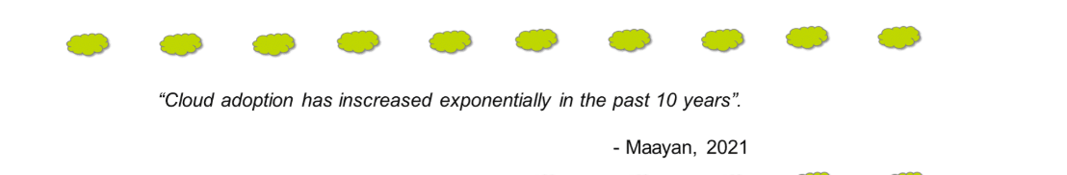
There are many reasons for this:
- 1
1
The perception that cloud hosting is cheaper than on premise (this is very dependent on the type of application being hosted);
- 2
2
Availability;
- 3
3
Composability; Composability = building a system using small, reusable components that can easily be combined, replaced or rearranged.
- 4
4
Scalability;
- 5
5
Security.
Certainly, cloud hosted applications lend themselves to cloud-based disaster recovery solutions (often via DR as a service (DRaaS) which is discussed in the next section).
The more a business is digitalised and automated, the more use it can make of cloud-based facilities.
Cloudification is the conversion of applications, data storage, and compute cycles to take advantage of cloud computing.
Cornell University, Anon, 2017
Cloudification is the conversion of applications, data storage, and compute cycles to take advantage of cloud computing.
Cornell University, Anon, 2017
To illustrate this, consider the example of blue-green (BG) deployments.
- Phase 1

Virtualised Environments
BG deployments are a mechanism used by companies that utilise a DevOps approach to production release. It relies upon having two, identical, virtualised environments available:
  - One is designated as production (Green);
  - The other is designated pre-production, staging or clone (Blue).
The beauty of a virtualised environment is that these two environments can be switched over at a moment's notice.
Blue-Green Deployment is a software deployment strategy used to release a new version of an application with minimal downtime and easy rollback.
Think of it as having two identical environments.
- 🔵 Blue = the current live version (the version users are currently using)
- 🟢 Green = the new version you are preparing
Users initially use the Blue environment.
Users

- Phase 2

New Code
Thus, the business will deploy the new code, patch or updated system into blue where it will be tested until the team are sure it is ready for release.
At that time, the two environments can be switched (often using DNS settings or a traffic manager) so that staging (blue) becomes production (green) and vice versa.
- Phase 3

Upgraded Environment
The newly 'downgraded' production environment (now blue) can be maintained while the newly upgraded staging environment (now green) is made available to the users.
- Phase 4

Problems?
If any kind of problem is discovered, the environment can be easily switched back while the problem is resolved. If no problems are encountered, the 'old' environment is upgraded and development continues on that.
Diagram showing BG Deployments explained above.

Blue green environment - (Millward, 2022)
This conversion process is not seamless, and there are a number of factors to be borne in mind when considering migrating an application or workload from on-premise to cloud hosting. These include:
Choosing whether to go with a single supplier or multiple suppliers.
The decision whether to use a hybrid cloud or fully public cloud model.
The conversion of applications to be 'cloud native'.

Phase 1 – Two environments
The company has:
Green → Live production system
Blue → Test/staging system
Both environments are identical.

Phase 2 – Install new code
Developers deploy:
- New code
- Updates
- Security patches
into Blue.
They test everything before releasing it.

Phase 3 – Switch environments
When testing is successful:
Users are redirected from Green → Blue.
Usually done using:
- DNS settings
- Traffic managers
Now:
Blue → Live system
Green → Standby system

Phase 4 – If problems occur
Simply switch users back.
Users → Green
This is called a rollback.
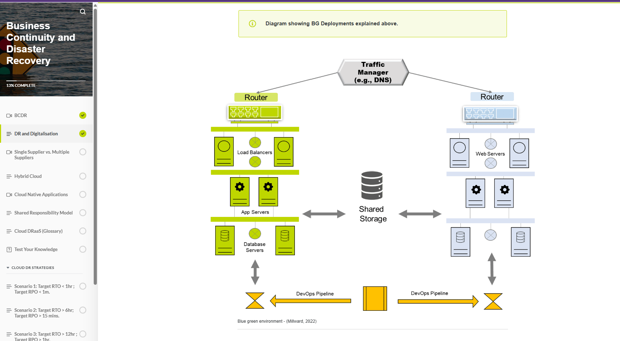
This conversion process is not seamless, and there are a number of factors to be borne in mind when considering migrating an application or workload from on-premise to cloud hosting. These include:
Choosing whether to go with a single supplier or multiple suppliers.
The decision whether to use a hybrid cloud or fully public cloud model.
The conversion of applications to be 'cloud native'.

Hybrid Cloud
Hybrid cloud is a variation on the multi-supplier model.
However, it usually denotes a combination of private cloud and public cloud (although the latter may also use a multi-supplier model).
There are many reasons to use a hybrid cloud model. For some, it can be more cost effective, especially if the user demand is periodic, not constant.
Some countries also have a privacy model where personal details of citizens are not allowed to be stored outside of the country; a hybrid cloud model can provide the guarantees that this condition is adhered to.
Absolutely! Here are concise notes you can save for revision.

Cloud-Native Applications (Short Notes)

What is a Cloud-Native Application?
An application designed specifically for the cloud using containers, microservices, APIs, and automation. It is scalable, resilient, and easy to update.

12 Principles (One-Line Notes)
- Codebase – One shared source code for all deployments.
- Dependencies – Clearly define all required software/libraries.
- Config – Store settings (e.g., passwords, API keys) outside the code.
- Backing Services – Use external services (database, email, storage).
- Build, Release, Run – Keep these stages separate.
- Processes – Run as stateless processes.
- Port Binding – Application provides services through network ports.
- Concurrency – Scale by running multiple instances.
- Disposability – Fast startup and graceful shutdown.
- Dev/Prod Parity – Keep development and production environments similar.
- Logs – Treat logs as event streams and centralise them.
- Admin Processes – Run maintenance tasks separately.

Key Concepts
- Stateless – The application does not store user session data between requests.
- Container – A package containing the application and everything it needs to run.
- API – Allows different applications/services to communicate.
- Microservices – Small independent services that each perform one task.
- DevOps – Developers and operations work together for faster delivery.

Cattle vs Pets
- Pets 🐶 → Repair the same server if it fails.
- Cattle 🐄 → Replace failed servers with new ones automatically.

Cybersecurity Example
A cloud-native banking application can automatically create additional login or payment service instances during heavy traffic or an attack, improving availability and resilience.

Exam Definition ⭐
Cloud-native application: An application built specifically for cloud environments using containers, microservices, APIs, and automation to provide scalability, resilience, and rapid deployment.
In summary, these guidelines advocate:
A shared repository for;
All developers;
A DevOps style pipeline;
Stateless Processes (often microservices);
Containerised Applications and;
An API driven development model.
Scaling is via the "cattle vs. pets" model (Bias, 2016) where, because each process is stateless, it can be easily replicated, and just as easily terminated when no longer required.
It also tackles the composability requirement via exposing services as part of a publicly available API. This approach (stateless with API) also lends itself to very flexible DR design and deployments.

Shared Responsibility Model
Virtually all of the major cloud service providers (CSP) such as Amazon (AWS), Google (GCP) and Microsoft (Azure) subscribe to a shared responsibility model that defines the security aspects of the cloud.
It can be (broadly) summarised as the CSPs are responsible for the security OF the cloud, whereas clients are responsible for the security IN the cloud.
Lane et al (2017) present a more detailed view as show in the table below.
C = Client; CSP = Cloud Service Provider
RESPONSABILITY | ON-PREMISE | SaaS |  | PaaS |  | IaaS
Data Governance | C |  | C |  | C |  | C
Endpoints Protection | C |  | C |  | C |  | C
User Access Management | C |  | C |  | C |  | C
Identity Infrastructure | C | CPS | C | CPS | C |  | C
Application | C | CSP |  | CSP | C |  | C
Network Control | C | CSP |  | CSP | C |  | C
OS Security | C | CSP |  | CSP |  |  | C
Host | C | CSP |  | CSP |  | CSP
Network | C | CSP |  | CSP |  | CSP
Data Centre | C | CSP |  | CSP |  | CSP
Table 2 Mapping responsability for data security & privacy requirements to cloud service models: (developed from Microsoft, Techtalk, IBM, and Amazon). From Lane et al (2017)
Shared Responsibility Model (Short Notes)
What is the Shared Responsibility Model?
A security model that defines who is responsible for security in cloud computing.
- Cloud Service Provider (CSP) = Responsible for security OF the cloud.
- Customer (Client) = Responsible for security IN the cloud.
Remember:
- OF the cloud = Cloud infrastructure.
- IN the cloud = Your data, users, and applications.

Responsibilities by Service Model
1. On-Premise
Customer is responsible for everything.

2. SaaS (Software as a Service)
Examples: Microsoft 365, Gmail.
- CSP: Applications, OS, servers, network, data centre.
- Customer: Data, user accounts, access permissions.

3. PaaS (Platform as a Service)
Examples: Google App Engine, Azure App Service.
- CSP: Infrastructure, OS, runtime.
- Customer: Applications, data, user access.

4. IaaS (Infrastructure as a Service)
Examples: AWS EC2, Azure Virtual Machines.
- CSP: Physical servers, networking, storage, data centre.
- Customer: Operating system, applications, data, user accounts.

Simple Rule
Service | Customer Responsibility
On-Premise | Everything
SaaS | Least responsibility
PaaS | Medium responsibility
IaaS | Most responsibility (except physical infrastructure)

Cybersecurity Example
A company stores customer data on an AWS EC2 virtual machine (IaaS).
- AWS secures the physical servers, storage, and networking.
- The company must secure the operating system, apply patches, configure firewalls, manage user accounts, and protect customer data.
If the company leaves the VM password as "admin123", AWS is not responsible—the customer is.

Exam Definition ⭐
Shared Responsibility Model: A cloud security model where the Cloud Service Provider secures the cloud infrastructure (security OF the cloud), while the customer secures their data, applications, identities, and configurations within the cloud (security IN the cloud).

Cloud DRaaS (Disaster Recovery as a Service) – Short Notes

What is Cloud DRaaS?
A cloud service that helps organisations recover systems and data after a disaster (e.g., cyberattack, hardware failure, fire).
Key idea: The cloud is not unlimited—it is a large, virtualised data centre managed by a cloud provider.

Common Cloud Providers
- AWS
- Azure
- Google Cloud (GCP)
- IBM
- Alibaba
- Rackspace

Important DRaaS Terms
- AG (Application Gateway) – Protects and load-balances applications.
- ASE (App Service Environment) – Isolates apps and supports auto-scaling.
- Availability – Percentage of uptime (e.g., 99.9%).
- Backup – Copies of data for recovery.
- Cosmos DB – Global database with high availability.
- Criticality – Importance of a system to the business.
- Databases (Sync/Async) – Methods of copying database data.
- GRS (Geo-Redundant Storage) – Data stored in multiple geographic locations.
- LRS (Locally Redundant Storage) – Multiple copies in one location.
- PITR (Point-in-Time Restore) – Restore data to an earlier point in time.
- Replication – Copying data to another server/location.
- Resilience – Ability to continue operating during failures.

Cybersecurity Example
A company is hit by ransomware. Its cloud DRaaS solution restores clean backups from a geo-redundant storage (GRS) location, allowing services to resume quickly and reducing downtime.

Exam Definition ⭐
Cloud DRaaS (Disaster Recovery as a Service): A cloud-based service that replicates and backs up systems and data, enabling organisations to recover quickly after disasters while improving business continuity and resilience.
Business and Infrastructure
When a business decides to migrate their systems to the cloud, there are several decisions that need to be made.
The first is the type of provisoning to select – in its most basic form this comes down to:
- IaaS (infrastructure as a Service – the cloud provider makes a number of virtual machines (VMs) available for the business to use and manage);
- PaaS (Platform as a Service – the cloud provider supplies a number of managed platforms that will host the businesses applications);
- SaaS (Software as a Service – the cloud provider hosts a number of applications (possibly from third parties) that the business can consume).
In this section we will concentrate on the use of the cloud as an alternative platform for DR purposes – this is often referred to as DR as a Service (DRaaS).

Virtual Private Clouds
Firstly, many cloud platforms will create applications within an isolated private network – a so called Vnet or ASE (application service environment - known as a VPC or virtual private cloud on AWS).
This is a good security measure but on some platforms – such as Azure – creating ASEs can have a time penalty which should be considered as part of the recovery period.
Most VPCs/ Vnets/ ASEs will have an application gateway (AG) which provides network address translation (NAT), a basic firewall and in many cases also provides load balancing.
This allows the application to have multiple virtual servers within the ASE which increases the resilience (and availability) of the overall solution.

Data and Databases
Data and databases are often a critical consideration for any application – and the same applies to a DR solution. Most cloud platforms provide redundant storage – for example Azure provides:
- LRS (local redundant storage);
- ZRS (zone redundant storage);
- GRS (globally redundant storage).
Thus if you have your main system (as well as your DR system) in the cloud then your cloud provider will automatically store up to 3 redundant copies of your data – either locally (L - the default) within an availability zone (Z) or globally (G).

Limitations
However, as with all automatic provisioning there are limitations with all these solutions. Taking the specific case of Azure :
- Local copies are stored in the same (virtual) datacentre – which means if something happens to that building all the copies will be lost.
- Zone redundant copies are kept within the same availability zone – which is another centre within the same geographic area but may be kilometres apart (for example in the Dublin zone there are 5 separate centres).
- The global option will store at least one copy in the 'paired' datacentre (within the Azure model each region is paired with another – for example Dublin is paired with Amsterdam).
The other consideration is latency, both LRS and ZRS are synchronous processes – so data must be confirmed as written to all locations; GRS is asynchronous where there is a delay (of 15 minutes or more sometimes) between the local write and the remote copy.
This introduces the possibility of lost data, and in most cases the remote copy is only accessible by Microsoft as default, and usually requires a failover to provide access.
Availability
It is decided by many factors including:
- bullet
the availability of the platform;
- bullet
the network;
- bullet
the components used in the system and;
- bullet
the overall design of the solution.
Availability must be expressed over a period in time – be that a week, a month or a year, and should be expressed as a percentage. A formula to calculate availability is given in table 1, where AST is agreed service time and DT is downtime.
Many platforms will offer SLAs (service level agreements) around availability and will pay service credits if they miss an agreed target – how useful this is depends on the criticality of the application – if the business will lose thousands of dollars an hour (or more) if an app goes down then that suggests a more rigorous DR solution is required.
Availability is also decided by the product of all the components contributing to the solution – generally the more components the lower the availability.
Availability Solutions
When considering availability solutions there are 3 options provided by Azure:
AVAILABILITY SETS
This is a feature that allows a virtual server to be paired with another so that the underlying platform will assure that at least one of the set is running and can be accessed.
AVAILABILITY ZONES
This is the provision of multiple data centres/ sites within a single geographical region.

AVAILABILITY GROUPS
A database technology that use shared storage, server clustering and synchronous
Database Administrators (DBAs)
There are several options to consider with databases too:

PITR
Point In Time Recovery / Restore
Referred to as "rollback" by traditional database administrators (DBAs).
This is the ability to restore (or rollback) a database to a previous version – up to 35 days old (depending on the system settings).

Although this is a very useful option you need to bear in mind if and how you can roll back the rest of your system to that older state as well.
- AOAG
Always On Availability Groups
From a DR perspective Azure offers AOAG, snapshots and log shipping as options to provide a database service, in order of preference, cost and availability (highest to lowest).

AOAG was discussed previously, it is the most expensive option requiring multiple active databases, servers and shared storage. Log shipping is cheapest (as the second server can be in standby mode) but not as immediate; snapshots is somewhere between the other two options and can be more complex depending on the amount of databases in use.
- CosmosDB
Multimaster Database Engine
Azure offers a specialist cloud database option known as CosmosDB. Cosmos is a multi-master, distributed database engine.

It provides high availability but the trade off is against performance and consistency – there are various operating models available that allow the user to select his/her preferred trade-off of all three.

Alhazmi and Malaiya (2013) carried out research around evaluating DR plans that used cloud facilities and provide a few theoretical solutions – it is available via the references.
The next sections present a number of practical solutions that have been implemented as part of commercial solutions.
Database Recovery Options – Short Notes
1. PITR (Point-in-Time Restore)
- Restores a database to a previous point in time (up to 35 days, depending on settings).
- Also called rollback.
- Useful after accidental deletion or data corruption.
Note: Other systems may also need to be restored to the same point.

2. AOAG (Always On Availability Groups)
- Uses multiple active database copies for high availability.
- Provides fast failover if one database/server fails.
- Most reliable but also the most expensive option.

3. Cosmos DB
- A cloud-native, globally distributed database in Azure.
- Supports multiple active copies (multi-master).
- Offers high availability, but there is a trade-off between:
  - Consistency
  - Performance
  - Availability

Comparison
Option | Purpose | Cost
PITR | Restore database to an earlier time | Low
AOAG | High availability with instant failover | High
Cosmos DB | Global, highly available cloud database | Medium–High

Cybersecurity Example
A company accidentally deletes customer records.
- PITR restores the database to before the deletion.
- AOAG keeps the service running if a database server fails.
- Cosmos DB ensures users worldwide can still access data even if one region experiences an outage.

Exam Definitions ⭐
- PITR: Restores a database to a specific previous point in time.
- AOAG: Uses multiple active database copies to provide high availability and fast failover.
- Cosmos DB: A globally distributed Azure database that balances availability, consistency, and performance.
- Alhazmi and Malaiya (2013) carried out research around evaluating DR plans that used cloud facilities and provide a few theoretical solutions – it is available via the references.
- The next sections present a number of practical solutions that have been implemented as part of commercial solutions.
Scenario 1: High Availability (Active–Active) – Short Notes
Requirements
- RTO < 1 hour → Recover in less than 1 hour.
- RPO < 1 minute → Lose less than 1 minute of data.
- Suitable for mission-critical systems.

Active–Active Solution
- Two identical systems run at the same time.
- Usually located in different regions.
- A Traffic Manager (TM) automatically redirects users if one site fails.
- Both systems receive updates simultaneously.
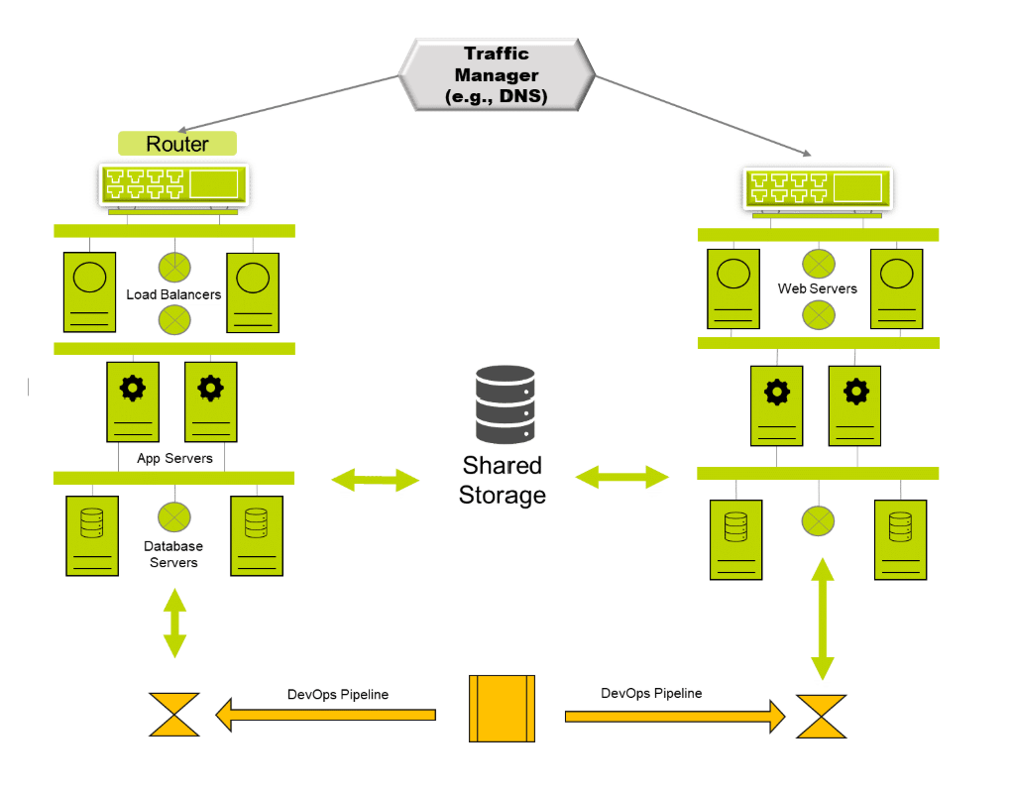

Database
- Use AOAG or Cosmos DB (multi-master).
- Data is synchronously replicated between both sites.

Advantages ✅
- Very high availability.
- Fast failover with little or no downtime.
- Minimal data loss.
- High resilience.

Disadvantages ❌
- Very expensive (two complete systems).
- Data corruption is copied to both sites because of synchronous replication.
- Cloud provider (vendor) failures may affect both sites.

Key Risks
- Data corruption → Corrupted data is replicated to both systems.
- Vendor outage → If the cloud provider has a major issue, both regions may be affected.

Cybersecurity Example
A large online banking system uses an active–active setup across two cloud regions. If one region is hit by a DDoS attack or suffers a hardware failure, the Traffic Manager automatically redirects customers to the second region, keeping online banking available with almost no interruption.

Exam Definitions ⭐
- RTO (Recovery Time Objective): Maximum acceptable time to restore a service after a failure.
- RPO (Recovery Point Objective): Maximum acceptable amount of data that can be lost.
- Active–Active: Two systems run simultaneously, providing high availability and automatic failover.

Scenario 2: Target RTO > 6hr; Target RPO > 15 mins.
- These requirements imply a medium criticality system. The recovery objectives (especially the RPO) indicate that an active-passive (aka warm standby) solution is appropriate, see diagram below.

- Active Passive Diagram.
- Therefore two systems would be deployed at all times – although the second would be inactive (I.e. passive) which will save on some utilisation charges and often on licensing as well. Code will be deployed to both sites simultaneously, but as site 2 is passive blue-green deployment is not an option.
- Data replication will usually be asynchronous and can be via standard provider mechanisms (e.g. GRS) although the architect should confirm the SLAs meet the RPO objectives. Database replication can be via snapshots or log shipping due to the reduced recovery time expectations. Switchover can also be via manual mechanisms rather than automated. Switchover would mean that all applications would need to run from the second site, and failback may be a more protracted exercise.
- As the table below describes, code and data is available but manual intervention is required to switch over systems.
CATEGORY | PROS | CONS | CAVEATS
Availability | Code is available in all regions, just need manual switchover. | Not automatic which introduces delays; processes also add delay. | May have manual process around invocation and approval - needs testing.
Recoverability | Alt region means recoverability would be same order as RTO. | Recoverability by original region would be slower. | Need to ensure all data replicated to alt region; RPO constrained by platform SLAs (without custom scripts).
Resilience | Alt region provides high resilience but not HA due to time delays. | Failover usually means region failover - expensive in time. | Cheaper/easier to use additional availability zones for resilience.
Data Corruption | Small replication delays may help address corruption risks. | Replication delays means data loss and higher RPO. | Needs careful tuning to mitigate corruption and avoid data loss - already higher than active-active.
Regions | Single vendor may make replication and switching easier. | Vendor errors may affect ALL regions - DR will not help. | Consider multi-vendor solution - more complex, possibly higher cost.
- This is a good and bad thing – bad in the fact that new processes and procedures around switchover will be required, and will need testing, but it offers the possibility of avoiding corruption.
- This is a highly recoverable system in terms of switchover to the other site (and within the stated time window) but recovery within the original site may take much longer – see the comments about fail back previously.
- If high availability is required it is wise to consider multiple load balanced servers at each site as switchover in this scenario is not a HA process.
- As discussed previously, longer time objectives mean that data corruption can be tested for and may not be replicated to the second site – but this would require additional testing and possibly scripting. The risk of vendor propagated errors still apply.

Scenario 2:

Medium Availability (Active–Passive / Warm Standby) – Short Notes

Requirements
- RTO > 6 hours → Recovery can take several hours.
- RPO > 15 minutes → Up to 15 minutes (or more) of data loss is acceptable.
- Suitable for medium-critical systems.
- 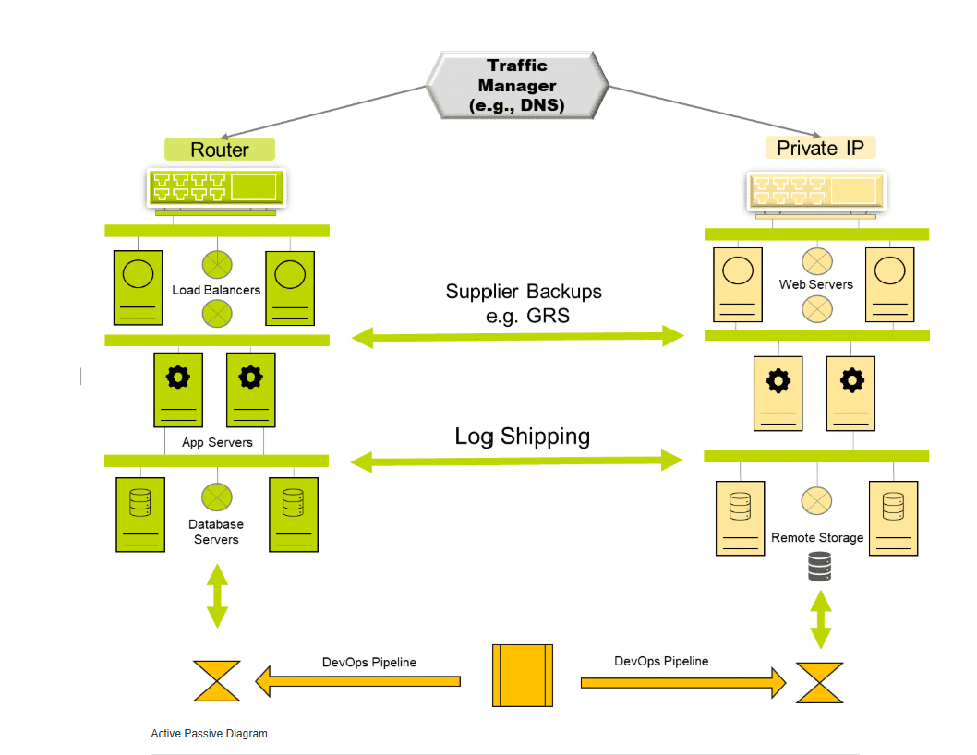

Active–Passive (Warm Standby)
- Two systems are deployed.
- Active site runs normally.
- Passive site is on standby and activated only if the main site fails.
- Manual failover is usually required.

Database
- Uses asynchronous replication.
- Databases can use Snapshots or Log Shipping.
- Data is copied with a delay, reducing cost but increasing possible data loss.

Advantages ✅
- Lower cost than Active–Active.
- Good disaster recovery.
- Less chance of replicating corrupted data due to delayed replication.

Disadvantages ❌
- Recovery is slower.
- Manual failover causes downtime.
- Some data loss may occur.
- Failback to the original site can take time.

Key Risks
- Manual recovery may delay service restoration.
- Vendor-wide outages can still affect both sites.

Cybersecurity Example
An e-commerce website uses an Active–Passive setup. If the primary data centre is hit by ransomware, administrators manually switch operations to the standby site. The website resumes within the RTO, but up to 15 minutes of recent transactions may be lost.

Exam Definitions ⭐
- Active–Passive (Warm Standby): One system is active while a second standby system is activated manually if the primary system fails.
- Asynchronous Replication: Data is copied with a delay, reducing cost but allowing some data loss (higher RPO).

Scenario 3: Target RTO > 12hr ; Target RPO > 1hr.
These requirements imply a low criticality system. The recovery objectives (both RTO and RPO) suggest that a DR cold standby solution would be appropriate, see diagram below.

Cold Standby Diagram.
The major advantage of this approach is the lower cost – it uses mechanisms such as reserved instances (where capacity is paid for but not deployed – hence reserved – saving on utilisation costs). Code is deployed on demand, although the deployment pipeline must have access to both sites and this should be regularly tested. Data is replicated asynchronously using standard provider mechanisms (e.g. GRS) but may not be instantly available to the business – the vendor may need to be involved, or a failover invoked.
The DR system will usually be built using deployment scripts, and data will be restored manually. Switchover will also be a manual process. However there is an expectation that any supporting (virtual) infrastructure – such as networks, etc, will be available and configured.
From an availability perspective, as described in the table below, it is assumed that code will be available from the pipeline. Data is available, but offline. There will be a need for additional processes, procedures and testing which should be carried out regularly.
CATEGORY | PROS | CONS | CAVEATS
Availability | Code is available in region, just need manual switchover. | Not automatic which introduces delays; processes also add delay. | Need manual process around restore, invocation and approval - needs testing.
Recoverability | Recoverability - assuming use of alt region would be same order as RTO assuming foundation service available. | Manual restore and switchover, extended build times due to delays with ASE, etc. | Need to ensure all data replicated to alt region; RPO constrained by platform SLAs and manual steps.
Resilience | This is not HA but makes restore quicker. | May require failover - expensive in time. | Cheaper/easier to use additional availability zones for resilience.
Data Corruption | Need to check any replication PLUS stored code/data - delays may not help. | Replication delays means data loss and higher RPO. | Needs careful tuning to mitigate corruption and avoid data loss - higher than Warm Standby.
Regions | Single vendor may make replication and switching easier. | Vendor errors may affect ALL regions - DR will not help. | Consider multi-vendor solution - more complex, possibly higher cost.
Assuming the above testing has been carried out, recoverability should be high – within the agreed time objectives. There is always a risk of delays due to having to run the scripts, and these should be factored into any risk assessments and test strategies.
This approach does not provide any additional resilience, so availability zones should be explored.
The replication of corrupted data may be able to be avoided – assuming automated/scipted checking is possible within the stated time objectives. Vendor propagated errors are still a risk.

Scenario 3 – Cold Standby (Summary Table Notes)
Availability
- Pro: Code is available; only manual restoration and switchover are needed.
- Con: Manual process causes delays.
- Note: Restore and approval procedures must be tested.

Recoverability
- Pro: Can recover within the target RTO if backups and infrastructure are available.
- Con: Recovery is slower because systems must be restored and started.
- Note: Ensure all data is replicated and backups are up to date.

Resilience
- Pro: Faster recovery than rebuilding everything from scratch.
- Con: Not High Availability (HA); failover takes time.
- Note: Extra availability zones can improve resilience.

Data Corruption
- Pro: Backups may help recover clean data.
- Con: Replication delays may still cause data loss.
- Note: Carefully manage backups and replication to avoid restoring corrupted data.

Regions
- Pro: Using one cloud provider makes management easier.
- Con: If the provider has a major outage, all regions may be affected.
- Note: A multi-cloud solution increases resilience but is more complex and costly.

Cybersecurity Example
A company keeps backup copies of its systems in another cloud region. After a ransomware attack, administrators manually restore the systems from backups. Recovery takes several hours, but clean backups help avoid restoring infected data.

Exam Tip ⭐
Cold Standby = Lowest cost, slowest recovery.
- ✅ Cheapest DR solution.
- ✅ Manual restore from backups.
- ❌ Longest downtime.
- ❌ Not suitable for critical systems.

Scenario 4: Target RTO > 48hr ; Target RPO > 24hr.
These requirements imply a non critical system. The recovery objectives suggest that a simple backup and restore solution would be suitable, see diagram below. The complete solution is backed up nightly using azure site recovery (ASR) and that would be the mechanism used to recover it as well.

DR Backup - restore.
Recovery can take up to 48 hours typically due to processes, access to data and so on. There is a risk that in the event of a major incident/ outage server (VM) capacity will not be available due to increased demand – if this is a DR solution and the system MUST be back up within a stated period I would strongly recommend the use of reserved instances – even though they add to the costs.
As with all the non-automated approaches, there is a need for new processes and procedures around backup and restore. The lack of reserved instances may increase timescales, and so will the need to involve purchasing and sales teams to get resources.
This is the most basic recovery mechanism available – but is more than acceptable within the stated time objectives. It doesn’t provide any resilience solution though.
As far as data corruption is concerned it is a major consideration here – as backups can (and do) often get corrupted and that would prevent any type of restore whatsoever. Regular testing is essential, as are multigenerational copies.
Vendor propagated errors are still an issue but there are backup and restore solutions that are multi-platform which may help mitigate this risk.
CATEGORY | PROS | CONS | CAVEATS
Availability | Std. mechanisms for B&R, regularly tested. | Delays in access & restore times; potential delay due to MS involvement. | Access to ASR may need MS involvement - depends on process used.
Recoverability | Based on restore of ASR backups, RTO dependent on ASR process times. | RTO and RPO pre-defined by ASR process. | Need custom scripts to improve RTO/RPO if required.
Resilience | Default is restore complete soln from backup. | No modular restore option as std. | Use AZ capability if provided.
Data Corruption | Can restore from previous good backup. | Corruption can affect backups. | Consider alt copies to mitigate.
Regions | Single vendor may make replication and switching easier. | Vendor errors may affect ALL regions - DR will not help. | Consider multi-vendor solution - more complex, possibly higher cost.

Scenario 4: Backup & Restore (Cold Backup) – Short Notes
Requirements
- RTO > 48 hours → Recovery can take up to 48 hours or more.
- RPO > 24 hours → Up to 24 hours of data loss is acceptable.
- Suitable for non-critical systems.

Backup & Restore Solution
- The system is backed up regularly (e.g., nightly using Azure Site Recovery (ASR)).
- If a disaster occurs, the system is restored from backups.
- No standby system is running.

Advantages ✅
- Lowest cost.
- Simple to implement.
- Suitable for non-critical applications.
- Can restore from an older clean backup if recent data is corrupted.

Disadvantages ❌
- Long recovery time.
- High risk of data loss.
- No high availability or resilience.
- Backup files can also become corrupted.

Key Risks
- Backup corruption → Recovery may fail if backups are damaged.
- Cloud resource shortages → Virtual machines may not be immediately available during a major disaster.
- Vendor outage → A single cloud provider failure may affect recovery.

Cybersecurity Example
A company's archive server is infected by ransomware. Since it is non-critical, administrators restore the server from the previous night's Azure Site Recovery (ASR) backup. Recovery takes about 24–48 hours, and one day's data is lost.

Exam Definitions ⭐
- Backup & Restore: A disaster recovery method where systems are restored from backup copies after a failure.
- ASR (Azure Site Recovery): A Microsoft Azure service that backs up and restores virtual machines and applications for disaster recovery.

Easy Way to Remember All 4 Scenarios ⭐
Scenario | Solution | Cost | Recovery Speed
1 | Active–Active | Highest | Fastest (minutes)
2 | Active–Passive (Warm Standby) | High | Hours
3 | Cold Standby | Medium | Slower (manual restore)
4 | Backup & Restore | Lowest | Slowest (1–2+ days)
Memory trick:
More critical system = More expensive DR solution = Faster recovery.
